**8. RESONANCE IN AIR COLUMN**

* 1. **AIM**

To find the velocity of sound in air.

* 1. **PRINCIPLE**

When an air column is excited by a sinusoidal force, for certain frequencies the amplitude of the air ‘particles’ is maximum. Standing waves are formed in the air column. This is referred to as resonance and occurs when the following condition is satisfied -

$$L= \frac{nλ}{4} or L=\frac{nV}{4ν}$$

Where

n is a odd - integer and can take positive values

L – length of the resonating air column

λ - wavelength

V – velocity of the sound

ν - frequency of sound wave

A node is formed at the closed end and anti-node at the open end of the tube.

**For different frequencies, the fundamental (n=1) and second resonance(n=3) lengths are found out.**

* 1. **EQUIPMENTS REQUIRED**

Table I: Equipment and the items required for performing the experiment.

|  |  |  |
| --- | --- | --- |
| **S. No.** | **Required item** | **Utility** |
| 1 | Tube with scale | To create a varying air column |
| 2 | Reservoir | To hold the water |
| 3 | Pinch cork | To adjust the water level |
| 4 | Rubber tube | Connection between tube and reservoir |
| 5 | Tuning fork set | Exciting frequency source |
| 6 | Rubber hammer | Exciting the tuning fork by hitting |

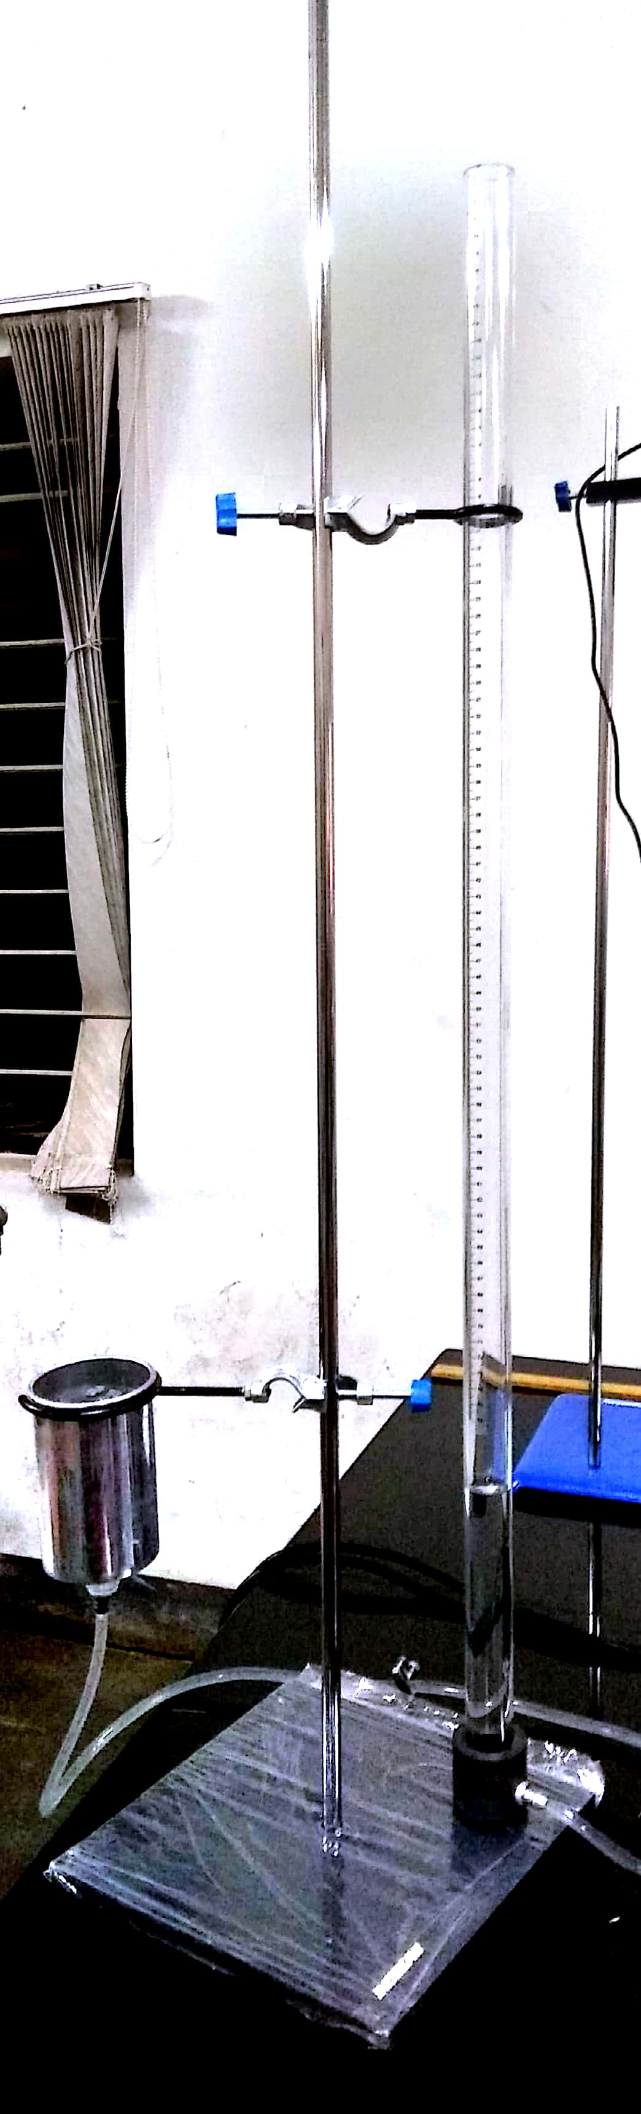

Figure 1: Photograph of the Resonance column apparatus.

**8.4 Procedure**

Two physical quantity need to be measured in this experiment.

Table II : The details of the physical quantities to be measured.

|  |  |  |  |  |  |  |
| --- | --- | --- | --- | --- | --- | --- |
| S.No |  | Independent/dependent | Measured  with | Measuring instrument’s | | |
| Minimum  (cm) | Maximum (cm) | Least count  (mm) |
| 1 | Length | dependent | scale | 0 | 76 | 1 |
| 2 | Frequency | independent | Different tuning forks are used. The values are mentioned on it. | | | |

b

1. Make sure that there is enough water in the reservoir, the water should be sufficient to make the air column length up to 5 cm.

**The length of air column can be changed by changing water level in the tube. It is done by raising or lowering the water reservoir and loosening the pinch cork.**

1. Make the air column length as 5 cm.
2. Choose a tuning fork of highest frequency. Hit it against a hammer and place it above the water tube. Listen carefully if there is any sound.
3. Tighten the pinch cork (not fully) and fix the reservoir at 40 cm. This will make the water level in the tube decrease slowly.
4. As the water level is decreasing, keep on exciting the air column till you hear a sound. Note down the range for which sound could be heard.
5. Now, adjust the length of the air column within the range and Note down this length (as *l*0) where the maximum sound is heard. This is the fundamental mode.
6. **Increase the length of the air colum further to obtain the second mode.** Note down this length of air column as *l*1.
7. Repeat this measurement for the all the available tuning forks.



Figure 2: Resonance column apparatus – measurements to be made

**How to measure resonace length:**

The resonance length is found out by lisenting to the sound created by the air column. The length corresponding to the loudest sound heard by you is taken as resonance length.

When the loud sound is heard, change the air column length by small amounts and repeat the experiment.

1. Plot a graph υ vs 1/4L. The slope of the line is related to the speed of the wave.

Table III: Measurements.

|  |  |  |  |  |  |
| --- | --- | --- | --- | --- | --- |
| S.No. | Frequency of tuning fork  ʋ |  | Secondmode (l1) |  |  |
| Fundamental mode  l0 | Wavelength  l1- l0 | Velocity |
|  | Hz | cm | cm | cm | ms-1 |
| 1 |  |  |  |  |  |
| 2 |  |  |  |  |  |
| 10 |  |  |  |  |  |

**8.5 STUDY QUESTIONS**

1. For a given frequency, is there is difference ín the loudness of sound for fundamental and second resonance ?
2. What is the effect of temperature on velocity of sound in air?
3. What happens to the resonance position if we use any other medium in place of water in the resonance column experiment?
4. What is meant by -correction? How it affects resonance?
   1. **FURTHER SCOPE OF EXPERIMENTS**
5. Excite the air column with the sound produce by mouth or any other source.
6. The speed of the sound is function of the temperature. Temperature of the air coulum can be changed and speed can be found out.
   1. **PRECAUTIONS**
7. We should keep the tuning fork above the mouth of glass tube with it’s “U” portion perpendicular to the open surface of glass tube.
8. Take reading after hearing maximum sound (Resonance).
9. Reduce the sounds present around in the room.
10. As the tube is long, it may fall down when hit.So perform the experiment where there is no movement of people.
    1. **SOURCES OF ERROR**
11. While keeping “U” part of tuning fork as parallel to the open surface of glass tube, it may cause the propagation of waves which will not give correct resonance pattern.
12. The measurement of resonant length depends on the perception of the individual.
13. If the experiment is not repeated by making fine changes when the loud sound is heard, there will be error in the length.

**8.9 THEORY**

* 1. **FURTHER READING AND RESOURCES**

**Internet**

Internet – AMRITA UNIVERITY LABS, www.amrita.olabs.edu.in

**Videos**

1. Amrita University. *Resonance column-MeitYOLabs*.

Retrieved from YouTube: https://youtu.be/IEq-ShFTAbY

1. AP Physics Lab 14:Resonance : https://youtu.be/LmNUsZBAoYM

**Bibliography**